**Name: Waleed Ahmed Shahid**

# fetch a single record via GET request (e.g. /data/Pakistan )

# list all records via a GET request

# Filter by one or more fields/attributes:

**The filter can be applied by multiple attributes.**

* Using only country=india filter

* Using country = india and matches-won=513

* Using country = india and matches-won(gte)=513

* Using matches-won(gte)=450

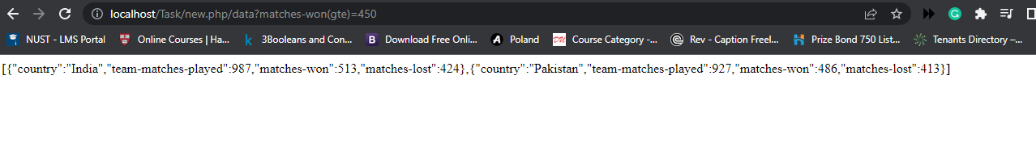

# sSort by one or more fields/attributes (e.g. /data?sort=matches-won)

**I have done sorting using one field only but it can be done with multiple fields. We can also apply filtering and sorting at the same time.**

**Sort using country(Ascending):**

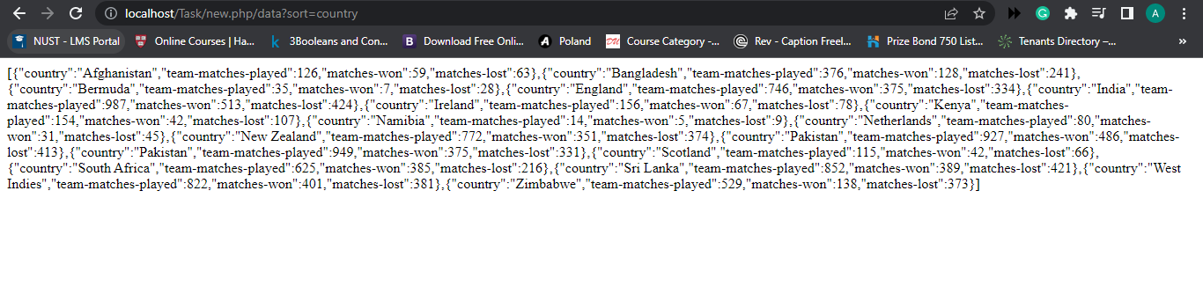

**Sorting + Filter:**

